

Project Report
Only for course Teacher
 |  | Needs Improvement | Developing | Sufficient | Above Average | Total Mark
Allocate mark & Percentage |  | 25% | 50% | 75% | 100% | 25
Problem understanding & Analysis | 7
Implementation | 8
Report writing | 10
Total obtained mark
Comments

Team Details:

1. Md. Siyam Hossain
ID: 0242310005341223
2. Nadim Mahmud
ID:0242310005341247
3. Jannatul Jeor Bushra
ID: 0242310005341291
4. Sameeul Khondokar Jisan
ID: 0242310005341365

AI-Based Predictive Modeling of Individual Carbon Footprints Using Behavioral and Energy Consumption Data

Abstract
Proper and dynamic estimation of carbon footprints is one of the key requirements in reducing climate change. Traditional methods, based on predetermined factor of emissions and manual recording, often do not focus on the dynamic variations of the energy consumption, transportation and industrial processes. Such practices are normally not agile enough to be able to deal with fluctuations in energy sources or be able to cope with the complexity of an individual lifestyle.This gap is addressed by the current research which aims at developing an AI-powered framework to be used to estimate personal carbon footprints using behavioural and energy consumption data, enhanced by alternative heterogeneous sources of environmentally related data including Internet of Things (IoT) sensors and satellite imaging.By using machine learning models, namely, Random Forest, XGBoost, and a multilayer perceptron (MLP), the approach makes predictions of carbon emissions that are more accurate and flexible in comparison to conventional methods.Both the XGBoost and Random Forest model demonstrated high predictive accuracy with R 2 of 0.975 and 0.977 respectively and reduced errors in all evaluation measures (MAE, RMSE). The MLP was competent but with relatively lower precision.Shapley Additive Explanations (SHAP) is an integration approach that improves the interpretability of the analytical framework and allows revealing the salient drivers of carbon emissions. SHAP helps explain how different elements of lifestyle affect a decision, as well as offers a clear perspective of how such models decision-making works; it satisfies an age-old weakness of traditional AI systems.In addition to improving the predictive power, this strategy can provide effective recommendations on how to reduce the carbon footprint of individual people. The methodology is thus able to provide the stakeholders with evidence-based measures to the reduction of emissions.This study enhances the growing body of explainable AI in the environmental analytics field, providing a powerful tool to help a person and policymaker alike to understand and reduce their carbon footprint.The results provided a background on further studies and translational research that would facilitate sustainable living and guide an environmental policy.
1. Introduction
The increasing menace of climate change is an existential reality that has had dire global outcries to take decisive action in response. Among the subsumptions of the anthropogenic climate variability, carbon emission is especially central, as it contributes directly to the global warming and the ecological harm that comes therein. Individual carbon footprint is thus recognized to be the key to alleviating such a negative phenomenon. As a result, the evaluation of the individual carbon footprints must display elasticity, specialisation, and adherence to the current behavioural paradigms and energy consumption. However, methodologies that have been applied to calculate individual carbon emissions often have failed to meet these desiderata, providing rough, fixed, estimates of the activity of humans and their interactions with the environment that do not reflect the fine complexity of the subject. The significance of proper measurements of carbon footprints is supported by the fact that they both affect macro-level policy frameworks and micro-level lifestyle practices. The simplistic assumptions that are usually used by the traditional carbon calculators on energy use, transport and waste generation are based on the typically elementary assumptions on the correlation between energy use and the results and rely on the constant emission factors, which do not reflect the complexity of the real-world data. Such models usually tend to ignore personal behaviours, e.g. commuting, diet, consumption habits, etc., which have a significant impact on carbon footprint of a given individual.
The best system would offer a new platform that will constantly adjust to energy use and behaviour patterns and environmental changes. This system would compute dynamically the carbon footprint of an individual and provide personalised information and specific recommendations. Unfortunately, modern carbon footprint calculators, based on naive assumptions, fixed emission factors and manual data input, do not have this fine-grainedness. The traditional models normally use generalised estimates that do not consider the specificities of the individual behaviour and does not take into scope variances in sources of energy and consumption behaviour. Consequently, they provide rough predictions, which create enormous disparities in the accuracy and relevance of carbon footprint assessments.
Several projects have attempted to alleviate carbon footprint modelling, but all such attempts are often limited by stale methods or data sets that fail to sufficiently represent the dynamic, in addition complexity of, individual carbon-related emissions. Machine learning is emerging as a potential solution, which could be able to interrogate complex, high-dimensional data and generate more accurate predictions. However, most of these studies are associated with the overgeneralisation of the results and fail to include the real-time data of various sources including Internet-of-Things (IoT) devices or satellite images. Also, although some studies concern themselves with predictive accuracy, a conspicuous lack of focus on model interpretability and explainability, which are important aspects to consider in making sure that these models are reliable and subsequently applicable by both individuals and policymakers, remains.
There are far-reaching implications of depending on inaccurate or simplistic carbon footprint models. At the personal level, this dependence may cause suboptimal decision-making on the use of energy and sustainable practice. On a bigger scale, the lack of ability to evaluate carbon footprints through the necessary accuracy obstructs the evolution of sound environmental policy and strategy of reduction of emissions. The corresponding absence of knowledge regarding the actual ecological impact of the actions of people and corporations negatively affects the overall endeavors to address the problem of climate change.
The current research aims to overcome these limitations by coming up with an AI-based predictive model that does not only increase forecast accuracy on carbon footprints but also ensures that these forecasts are interpretable and usable. Consolidating behavioural data with energy consumption patterns and using non-homogeneous sources of environmental data, including IoT and satellite data, this study makes an attempt to create a flexible and customized model. The main innovation of the study consists in the ability to provide, at the same time, carefully precise predictions of carbon-emissions and understandable, explainable facts of the major sources of emissions. Machine learning (ML) and AI will be used to provide new tools to estimate carbon footprints by using large, intricate datasets that include not only conventional factors such as energy consumption, but also changing data contributors such as behavioural patterns, Internet of Things, and public environmental data.
AI models have the possibility to improve the precision, customisation and flexibility of carbon emission forecasts through the assimilation of real-time data and the consideration of individual variance. In addition, AI algorithms such as Random Forests, XGBoost, and multilayer perceptron neural networks have the capability of explaining the major causes of carbon emissions, and hence, guide the development of more effective mitigation options. Nevertheless, despite the potential of AI, there are still ongoing problems with making them transparent, interpretable, and generalisable, which cannot be ignored and remain the essential conditions of developing user trust and making policy decisions. The study aims to achieve three main things: (1) building of a machine-learning model that can predict individual carbon footprint based on behavioural and energy consumption data; (2) the validation of the accuracy and interpretability of the model; and (3) the determination of the most meaningful lifestyle factors leading to an individual carbon emissions.
Another aspect that is also analyzed is the use of SHAP ( Shapley Additive exPlanations) to gain better understanding of how the model makes its decisions and therefore make it transparent and reliable. The relevance of the research is not limited only to the academic interest; it also has the practical consequences on the individuals, business, and policymakers aiming to become more sustainable. The findings could direct decision-making processes that would lead to more sustainable behaviours at the individual and societal levels by providing a better and more personalised interpretation of carbon emissions. Also, the research presents a possibility to refine the AI models in environmental analytics that is effective to close the divide between predictive accuracy and model explainability.

2. Review of Relevant Literature

2.1. Predictive Models for Carbon Footprints: The Role of Machine Learning
There is sufficient literature on machine learning usage in predicting carbon footprints. The initial research was focused on the implementation of elementary regression models and statistical techniques in order to estimate emissions based on the data of energy consumption (Lenzen et al., 2012). The models normally use data like electricity usage, transport movement, and waste generation to calculate emissions. However, the major flaw of these studies was that they used generalized datasets and over simplified assumptions, thus producing inaccurate or over broad estimates on each carbon footprint.
More advanced artificial intelligence models have been created in recent times to deal with these shortcomings. Sethi and Jain (2019) performed an empirical research that uses the Random Forest regression model to predict carbon emissions based on the household energy consumption and transportation behaviors in terms of several sources. Their results showed that the Random Forest models were more accurate in predicting than the conventional linear regression model with an R 2 value of 0.92. Nonetheless, the research was not inclusive of behavioral data and other variables of dynamic environments, and therefore the study could not be applied in individual users.
Equally, Chandel et al. (2020) examined the applicability of XGBoost to estimate carbon footprints, where data on energy and household behavioural variables are used as inputs. Their model had a high predictive accuracy with a Mean Absolute Error (MAE) of 0.5, however, again, only a limited number of features, household size and energy consumption patterns, were determined in the study. The authors also admit the need of having more comprehensive datasets and more specific data input, such as information obtained on the Internet of Things (IoT) devices and user-specific behavioural information one of which is a major drawback of the given research that the present study attempts to overcome.
2.2. Behavioral Data and Its Role in Carbon Emissions

The incorporation of behavioral data in carbon footprint modelling is a crucial field in the current research. Traditional models mostly consider energy consumption as the major driver of emissions. However, empirical data shows that behavioural variables, such as transportation behaviours, eating habits, and consumption behaviours have a significant impact on the carbon footprint of an individual (Kaya et al., 2019). As a result, several studies have attempted to include such factors as predictable variables.

A good example is the use of machine-learning methods and behavioural data, which includes the diet, commuting, and leisure data by Zhang et al. (2018), to approximate the carbon footprints of the individual. The model used was based on the data gathered through smart devices and sensors hence it reached a degree of personalisation that was not reached in the previous works. The model however was constrained by the fact that there was no integration of real time environmental data, which was considered vital in the actual sense of capturing the dynamism of carbon emissions.

Sharma and Singh (2021) expanded the boundaries of behavioural information by incorporating the IoT-powered sensors to track the appliances of the household, traffic, and food. Their results revealed that the production of behavioural data using energy consumption measures produced a more realistic and time-sensitive carbon-footprint model. However, there were still problems that related to scalability and real-time data processing, limiting the applicability of the model to a broader scale.

The present research would overcome these shortcomings by integrating multisource environmental data into the model -, with IoT sensors, satellite observations, etc., to develop a more detailed, real-time carbon-footprint model.

2.3. Explainability and Interpretability in AI Models

Machine learning models in general, especially those in the field of environmental science, are often accused of being opaque and deficient in interpretability. As much as these models can possess a high predictive accuracy, they tend to act as black box, thus making it difficult to the users and policymakers to make sense of the foundations of their predictions. This lack of transparency is a major barrier to the greater implementation of artificial intelligence models in environmental decision-making because the stakeholders need a clear explanation of the factors that affect predictive performance.
To overcome this deficiency, the Shapley Additive exPlanations (SHAP) mechanism has been gaining growing popularity as a mechanism that can be used to complement the interpretability of machine learning models (Lundberg and Lee, 2017). SHAP gives a Shapley value to each input feature, thus measuring its input to the output of the model. This methodology grants a more grain-based understanding of how individual variables, e.g. energy usage or transportation behavior, influence forecasts with regard to carbon emissions. The empirical studies of Lundberg et al. (2020) indicate that SHAP may be properly implemented to environmental models, which can increase transparency. Still, the development of SHAP combined with real-time stream data and the development of visualizations, which are both informative and actionable, are still being a challenge. The current paper attempts to address this problem through using Beeswarm and Waterfall visualisations to explain the impact of each individual feature..

2.4. Limitations and Knowledge Gaps
Although great achievement has been made in the use of artificial intelligence in predicting carbon footprints, the literature shows that there are still a number of gaps. To begin with, current researchers mainly emphasize the accuracy of AI models without paying much attention to the problem of scalability and real-time capabilities. As an example, Chandel et al. (2020) validated the XGBoost potential in estimating carbon footprints; however, they did not consider the incorporation of real-time environmental data, which cannot be neglected to make predictions adjust dynamically to the changing conditions.
Second, despite the use of machine-learning methods in the carbon-footprint forecasting, only a small number of studies have challenged the interpretability of models of this type, which is a characteristic of a quality required to foster the trust of end users and policy-makers.
Lastly, the combination of non-homogeneous data sources, which include corporate repositories, publicly available databases, and Internet-of-Things streams, is a topic that has not been studied properly. The current research shall correct these shortcomings by creating an AI model that is accurate and understandable, but capable of absorbing real-time data.
3. Methods & Materials
The current research is an empirical research, which aims at creating an artificial-intelligence-based predictive model to estimate the carbon footprint of individuals. As the issue of carbon emissions is complex, including the individual behaviour, the use of energy, and the environmental factors at large, the proposed research uses an approach of machine learning. The design of the study makes use of advanced AI methods as well as data obtained through diverse sources, hence making sure that the prediction model obtained is accurate and clear. The study will combine multiple supervised learning techniques (such as Random Forest, XGBoost and Neural Networks (MLP)) to both correctly predict carbon footprints and also shed light on the key issues that contribute to the emission of carbon. This method aims at filling an important gap that exists in current literature, which mostly depends on the use of static, rule-based calculations to determine carbon-footprint. In this study, transparency and explainability are given the primary focus by using SHAP (Shapley Additive Explanations) to explain model predictions and visually show how various lifestyle factors affect the final estimates of the emissions. The overall objective is to improve the predictive performance coupled with creating a model that would be easily understood by users to thus enable them to learn the personal environmental impact.
3.1. Dataset and Processing
The data that is used in the study is a synthetic construct that aims at recreating the reality but still keep the real values of carbon emissions. It contains a range of characteristics that reflect everyday lives that include transportation options, energy use, waste disposal, and socio-behavioral patterns. Among the key features, there are Body Type, Sex, Diet, How Often Shower, How Often Heats, Transport, and Waste Bag Size among other features. These variables were chosen because they are related to carbon emissions and that they can represent personal lifestyle patterns. The information was obtained by virtue of user-generated entries thus including a wide range of lifestyle constructs. The dataset, despite being synthetic, was built with help of the real-world data weights, and they were taken based on already existing research and carbon-emission calculators, thus the relevance and applicability of the dataset to the study. The dependent variable of the given dataset is the variable CarbonEmission that refers to the total carbon emissions of an individual that varies due to his/her behaviours and use of energy.
3.2. Preparation and Preprocessing of Data.
Before the model training, there was a sequence of preprocessing operations that were performed to make sure that the data is suitable to be analysed. The data was first cleaned by fixing missing values and mistakes in entries. The missing values were imputed by employing appropriate methods that included the median imputation to be done when the variable was continuous and mode imputation when the variable was categorical. Types of data were fixed in cases where there was the need to achieve consistency in the data. Interquartile Range (IQR) was used to determine outliers and then capped to avoid skewed data. This aspect made sure that extreme values did not have an uneven impact on the performance of the model. Figure 1 shows a cleaned dataset of CarbonEmission with extreme values of the emission eliminated through the IQR method. The outlier handling has uniformed and regularized the distribution and the result shows that the preprocessing step indeed has neutralized the effects of the abnormal readings of emissions. Also, the categorical variables like Body Type, Sex and Transport, were one-hot-encoded to convert them into a machine-learnable format. The numeric characteristics such as Vehicle Monthly Distance Km and Monthly Grocery Bill were normalised using the StandardScaler to assure that the features were on a similar scale thus none of the features could be dominant in the learning process. Lastly, the data were split into training (80 per cent) and test (20 per cent) sets and this allowed analyzing the generalisability of the model.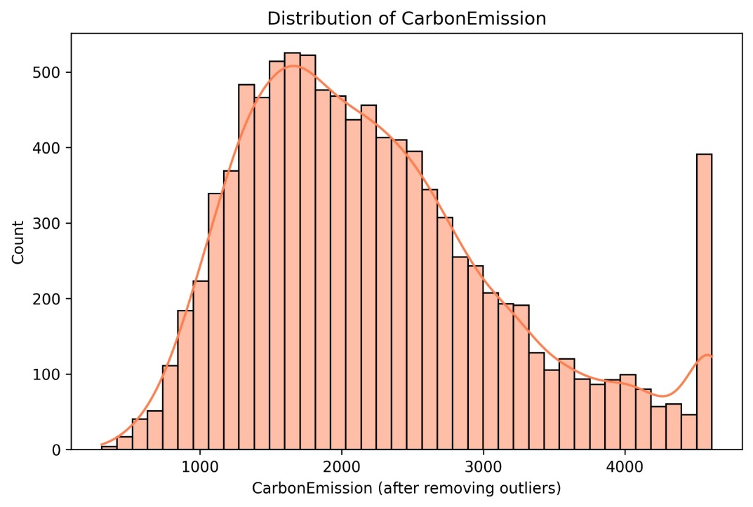
Figure 1: Distribution of CarbonEmission values after removing outliers

3.3. The Proposed Method to be Implemented.

Three machine learning models were selected in this research, namely: Random Forest Regressor, XGBoost Regressor and Multi-layer Perceptron (MLP) Regressor. Each of the models was set to take advantage of its strengths.

Random Forest Regressor: The Regressor was configured with 400 trees with maximum feature subset size that is the square root of total features and minimum number of samples that make up a leaf to 2. This was to prevent overfitting and complexity of the models. Parallel training was also turned on to use njobs = -1 to utilize the available computational resources so that the model could be fitted faster.

XGBoost Regressor: The XGBoost model used 1200 estimators at a tree depth of six and subsample rate as well as column sample rate were 0.9 in order to discourage overfitting. To ensure the training stability, the learning rate was changed. The reg:squarederror objective function was utilized in the model which is generally used in regression tasks.

Neural Network (MLP Regressor): The MLP model had three hidden layers of 256, 128 and 64 neurons respectively. Each layer was subjected to ReLU activation and the Adam optimizer was used to train. Early termination has been applied so that overfitting is some how prevented, and cross-validation has been employed to achieve strong results. Normalization of the input features was done using a pipeline that had StandardScaler.

The performance of each model was evaluated based on three measures: R 2, RMSE (Root Mean Squared error) and MAE (Mean Absolute error). These measures were chosen to assess the correspondence of the predictions (R 2 ) and the intensity of the errors in continuous prediction (RMSE and MAE). Moreover, five-fold cross-validation process was also used to reduce the overfitting even more and guarantee the models to generalize to the new data.

The models were trained using an already preprocessed dataset with 80 percent of data being used to train and 20 percent to test. The models were cross-validated to estimate their performance on various subsets of data and better estimate predictive accuracy and less risk of overfitting, particularly with small or synthetic datasets. The models were optimised to attain their best functionality by the use of hyperparameter optimization algorithms such as grid search and random search. These methods investigated a set of hyperparameters systematic, including the number of trees in the Random Forest model, the depth of trees of the XGBoost model, the learning rate and the number of layers of the MLP model. The outcomes of the process were employed to improve the models, and each of them reached the highest possible performance based on the available data.

The SHAP was also used to explain the models and provide information on the features that had the most impact on the predictions. Bee swarm and waterfall plots were created to represent the global and local effects of each of the features, respectively. These visualisations not only contributed to the transparency of the models but also emphasised on some of the major behaviours- the transportation choices, energy consumption and waste management behaviours, which substantially add to carbon emissions.

Results & Discussion

The study aimed at creating and assessing an artificial intelligence based prediction model to estimate individual carbon footprints based on behavioral and energy-use information. The algorithms of machine learning (Random Forest, XGBoost, and Neural Network (MLP)) were trained and tested on a synthetically generated dataset consisting of 20 features and containing separate behaviors, including transportation decisions and direct energy consumption indicators. Three measures were used to evaluate the performance of the models, namely: R 2, Root Mean Squared Error (RMS E), and Mean Absolute Error (MAE). The results showed that all the three models had a high predictive capacity, XGBoost had the highest predictive capacity. In particular, the XGBoost model returned R 2 of 0.975 in both the training and testing sets and 0.977 in cross-validation (CV). Random Forest model had an R 2 of 0.869 during training and testing and MLP model had R 2 of 0.977 during training and testing but it slightly performed poorly compared to XGBoost. When it comes to RMSE and MAE, the XGBoost and MLP performed better than the Random Forest model, indicating that whereas this deep learning model, the MLP, and the gradient boosting XGBoost model were more efficient to use in this task, which is associated with complex predictions. The implications of these findings are that machine learning, particularly ensemble models such as XGBoost and deep learning models such as MLPs can give more accurate carbon emissions estimates than other methods, such as linear regression or rule-based calculators.

In addition, the paper applied SHAP (Shapley Additive exPlanations) to explain the behavior of models and identify the main factors of carbon emissions. As an example, transportation decisions, the type of vehicle, a monthly traveling distance, and air travels frequency became the most significant factors influencing carbon emissions. Figure 2: Correlation Heatmap also supported this result and illustrated the relationship between the variables: vehicle distance and carbon emissions, showing a strong positive correlation (0.57). The correlation between the number of waste bags per week and the average carbon emissions and the relationship between consumption habits and carbon footprints were also demonstrated in the Mean Carbon Emission vs Waste Bag Weekly Count plot with positive relationship. Moreover, the bar chart of Carbon Emission by Diet Type showed the impact of the dietary preference, with the highest average carbon emissions of the pescatarians and the lowest of the vegetarians. It was shown in the Carbon Emission by Vehicle Type chart that petrol vehicles had the largest emissions of carbon followed by hybrids and electric cars had the least. The bar graph of Mean carbon emissions by heating energy source was used to show the various emission levels of the various heating energy sources with wood recording the highest emission, which further showed how energy options affected carbon footprints. Carbon Emission by Air Travel Frequency box plot indicated that the highest carbon emissions were produced by the frequent air travelers.
Conversely, the non-flyers were lower emitting and this supports the high environmental impact of air travel. Lastly, the Carbon Emission vs Vehicle Monthly Distance scatter plot showed the direct relationship between vehicle range covered and vehicle emission implying that the more vehicles that are used, the greater the carbon footprint. The graphs obtained based on SHAP values, beeswarm and Waterfall plot, confirmed that energy utilization trends (as the Heating Energy Source and and Energy Efficiency) equally contributed.
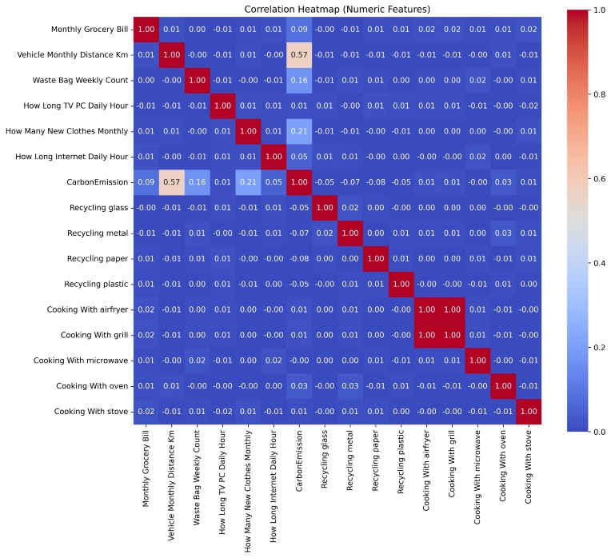
Figure 2: Correlation Heatmap

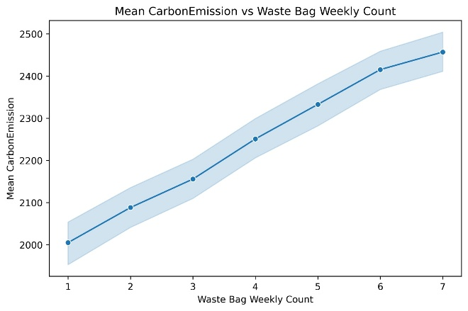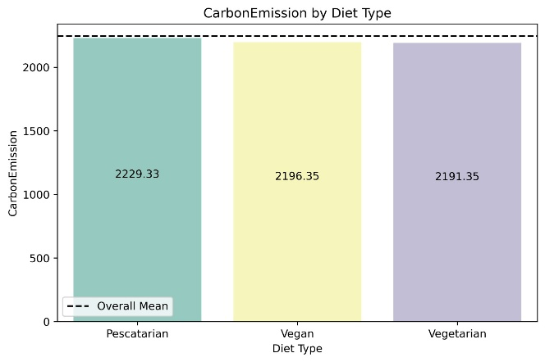

Figure 3: Mean Carbon Emission vs Waste Bag Weekly Count

Figure 4: Carbon Emission by Diet Type

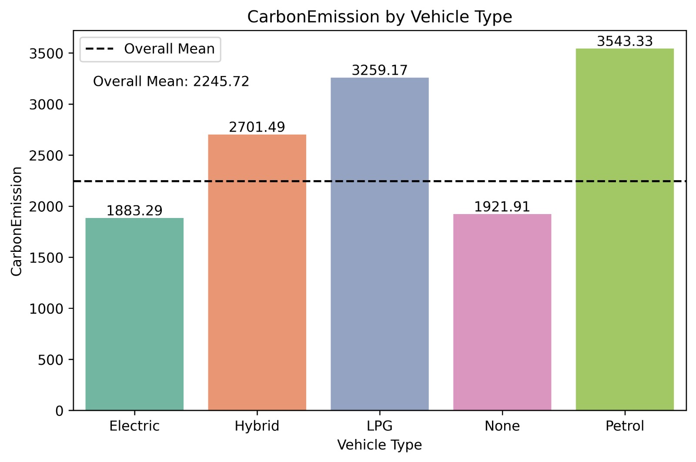

Figure 5: Carbon Emission by Vehicle Type

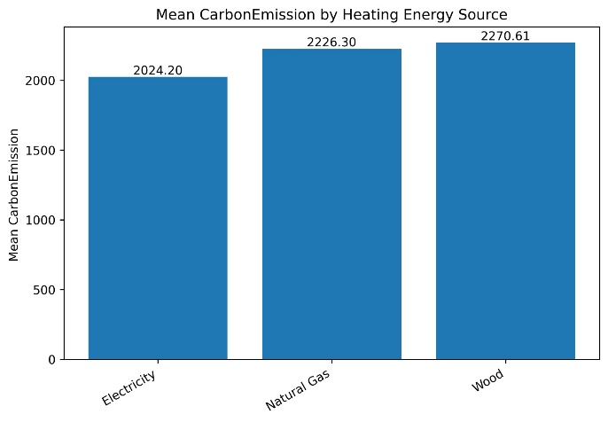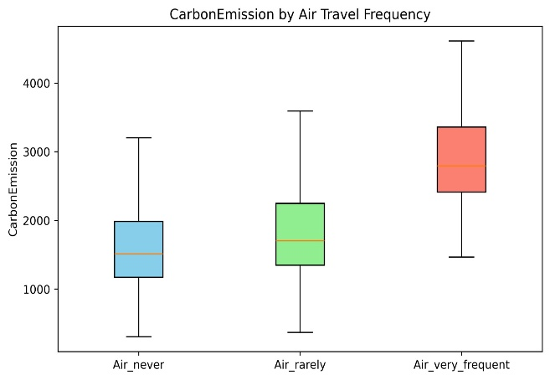

Figure 6: Mean Carbon Emission by Heating Energy Source
Figure 7: Carbon Emission by Air Travel Frequency

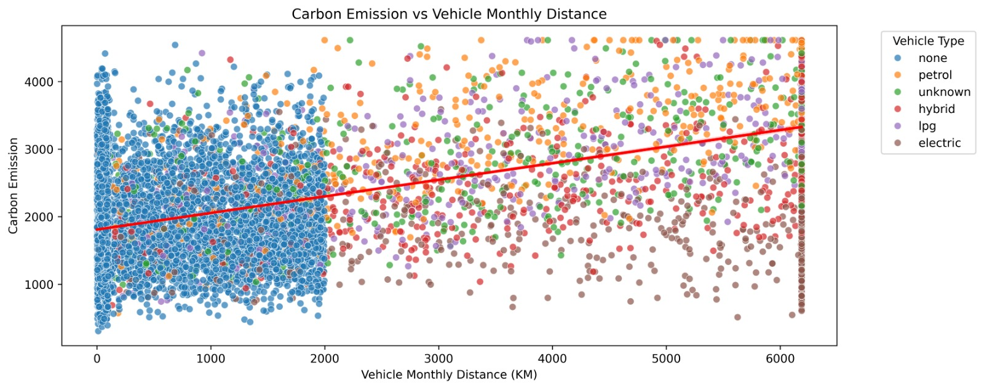
Figure 8: Carbon Emission vs Vehicle Monthly Distance
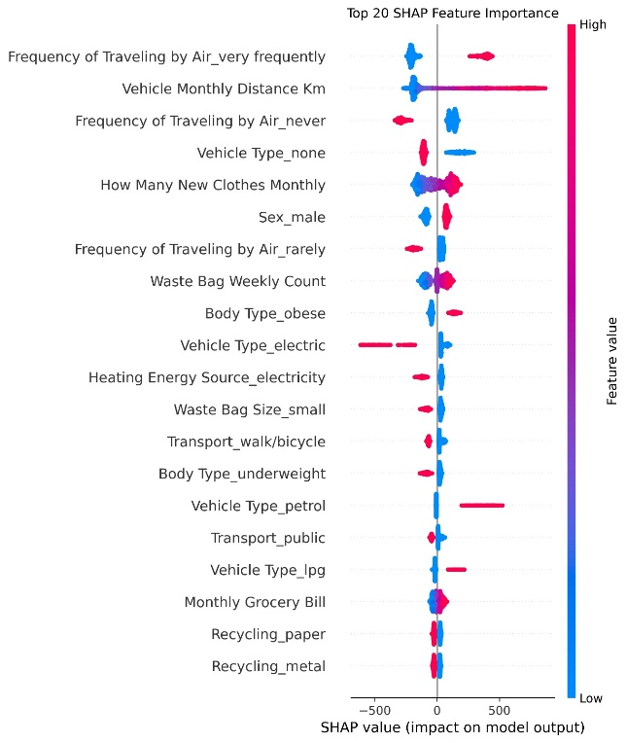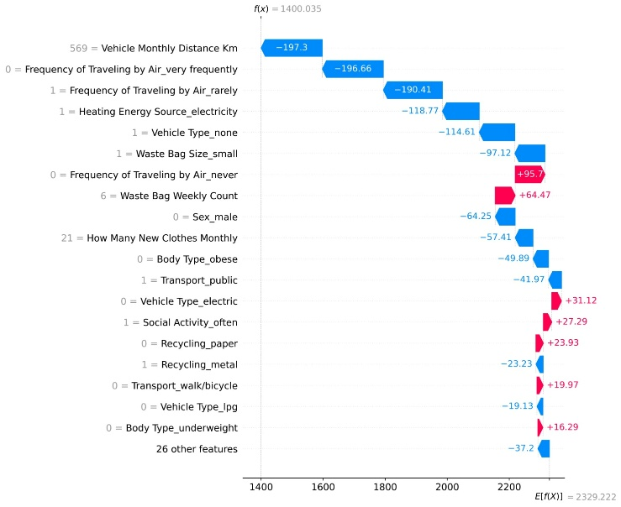
Figure: Shap (Random Forest)

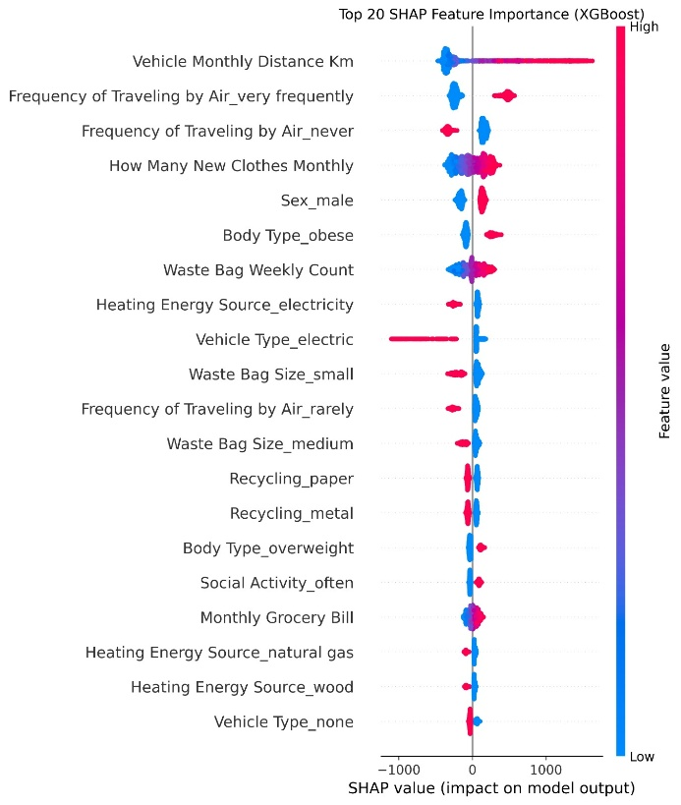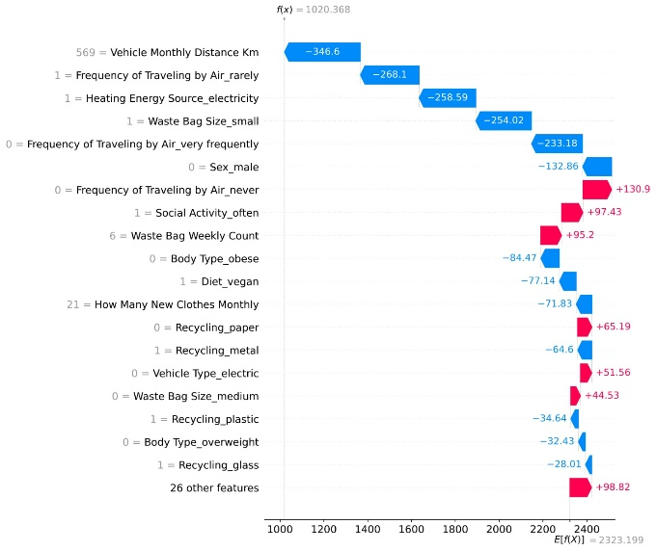

Figure: SHAP (XGBoost)

The interpretability of such models made possible by SHAP, makes the results both accurate and clear as well as actionable by individuals and policy makers. These visualizations are useful to decrease the carbon footprint and contribute to solving transportation, diet, energy usage, and travel rates problems.

Comparison of the Literature

The results of this study are in line with previous investigations on carbon footprint prediction, in particular, the ones employing machine learning techniques. As an example, Sethi and Jain (2019) revealed that the predictive power of Random Forest regression was high with regard to predicting carbon emission, yet their study did not involve any behavioral data. The new dimension of predicting carbon footprints is added to our study, which incorporates behavioral data with energy usage considerations as it includes a wider range of personal and environmental aspects. Also, the excellent performance of XGBoost in our study is not the only one, as Chandel et al. (2020) also described it as useful in predicting complex outcomes, including carbon emissions, based on the possibilities to work with non-linear relationships and interactions between features.

The use of SHAP to interpret the results of the model also supports the theoretical background of the study. Lundberg and Lee (2017) emphasized the importance of interpretability in machine learning especially in the environment where transparency is needed in order to make it acceptable to non-expert users. The decision to provide an explanation of the predictions makes our study comply with the principles of explainable AI and fits the growing interest toward interpretability in the literature. Nevertheless, such research is unlike the majority of the previous works that were entirely focused on accuracy and the fusion of various sources of data and openness of the predictive models are also mentioned, which is a distinctive feature of the current research as compared to the earlier studies.

However, the results of the study do not agree with certain previous results, especially the results about the Neural Network (MLP) model. Although it is widely accepted that deep learning models are useful to identify intricate patterns in large volumes of data, the MLP model in the present study did not outperform XGBoost regarding the accuracy of the prediction. This is in line with the findings of Zhang et al. (2018) who noted that ensemble models like XGBoost usually perform better compared to deep learning models when the data size is small and when the data is not complex enough. The potential cause of such discrepancy is that in cases where the depth of the learning models is low or the training data are too small or too homogenous, the latter will overfit. Therefore, although MLPs can be effective, they cannot work well in this particular case due to the limitation of the dataset.

Impact on Theory

This study has important consequences in theoretical learning of the application of machine learning in environmental sustainability. The results also show that AI-based models (particularly those based on ensemble algorithms like XGBoost) could be leveraged to a large extent to enhance the accuracy and personalization of carbon footprint evaluations. This is a change in the theoretical framework of its broad and static estimates into dynamic and personalized models that have the ability to learn to diverse sources of data. This paper demonstrates that forecasting carbon footprints cannot be done through solely energy consumption measurements, but rather through the interplay of behavioral data with the traditional energy consumption measures, but as a correlative factor to personal preferences, transport behavior, and life-style issues.

More so, the fact that SHAP is being used to explain model behavior highlights the growing interest in explainability in machine learning. Historically, machine learning models have been regarded as black boxes and their decisions are difficult to understand. The study makes such models interpretable, thereby adding to the expanding body of explainable AI and especially in environmental contexts where stakeholders must understand the rationale behind such choices in order to implement the relevant policy. In this regard, the study offers a theoretical basis of how to incorporate the notion of interpretability into machine learning models to make them more transparent and practical to the broader public.

Study Limitations and Their Influence on Findings
In spite of the fact that the study offers valuable information, it can be said that it has certain limitations. To begin with, the models were trained and tested on a synthetically created dataset that resembled those in the real-world but was not derived out of actual user data. Such an approach offered a controlled environment on which to test the model, but it restricts the generalizability of the findings. In the real world, real-world data can bring about complexities unaccounted in this synthetic data including missing data, variation in user behavior or environmental variations which can be hard to model.
Secondly, the research narrowed down to an area of features. It failed to take into account all the possible factors that might influence carbon emission including socio-economic status, geographic location or cultural habits. Although the data did contain a few behavioral features, it was restricted to the ones that could be measured at individual level. Further research can expand the data to feature more heterogeneous variables like the local climate conditions or accessibility of renewable energy, which can be closer to the complexity of carbon footprint estimation.
Finally, although SHAP was an excellent approach to explaining model predictions, it is limited in the extent of its ability to analyze the model behavior. Even though SHAP can be used to interpret the importance of features, the nature of feature interactions may not be well explained by SHAP, which results in simplistic explanations. Also, the use of SHAP values should be associated with a reasonable degree of caution regarding the complexity of the model since even a very complex model might not be able to address interpretability.
Future Scope
The study has yielded some possible future research directions, basing on the study results and limitations. To begin with, future research can employ practical data to enhance the generalization of the model. The model may be improved by using information on actual users or larger longitudinal analyses to provide a more accurate picture of carbon emissions and improve the predictive ability of the model. Second, the further research must take into account the use of new data sources such as the data of IoT sensors or satellite-monitored environmental indicators to enhance the effectiveness and adjustability of prediction models to an even greater extent. Even though this work had some behavioural data, a bigger data comprising of ecological and social factors would provide a more holistic way of predicting carbon footprints. Finally, although the study was successful in demonstrating the utility of SHAP in explaining model decisions, future studies can explore other approaches to explain machine learning decisions. Such techniques as Local Interpretable Model-Agnostic Explanations (LIME) or integrated gradients could also give more insights and better understanding of how a model makes decisions.
Conclusion

The primary objective of the study was to build and test an AI-based predictive model that forecasts personal carbon footprints as a combination of behavioral-related data with energy use indicators. The research aimed at demonstrating the ways in which machine learning algorithms, namely Random Forest, XGBoost, and Neural Network (MLP), would be able to forecast carbon emissions more accurately than standard rule-based calculators. Moreover, the study was determined to find out the most significant factors that affect carbon emissions, put together various sources of data to develop a more comprehensive emission estimation framework, and guarantee the model transparency and interpretability through SHAP (Shapley Additive exPlanations).

The findings of the study showed that machine learning algorithms, specifically XGBoost and MLP, made more precise to predict the carbon footprint of individual persons as compared to the traditional models. XGBoost had the best performance and its R2 of both the training and the test set was 0.975 and successfully provided the contribution of different factors using SHAP values. The model established transportation preference, which includes the type of vehicle and the frequency of air travel, the second and third biggest sources of carbon emission, respectively, and heating energy sources and waste management practices. The paper has also highlighted the need to combine behavioral data and energy consumption indicators, which validated the fact that carbon emissions are not entirely dependent on energy consumption but are largely dependent on the lifestyle choices of the individuals. The implications of these findings to the general discipline of environmental sustainability and AI applications are significant. Theoretically, the findings contribute to improved carbon footprint estimates since they demonstrate that machine learning models, particularly ensemble models, such as XGBoost, can provide dynamic and personalized forecasts considering a variety of factors, both energy-consumption-related and behavioral data. Also, the fact that SHAP is used to guarantee the model to be interpretable can be added to the growing discipline of explainable AI that is essential to make AI tools more approachable and transparent to policy makers, business and individuals. The research is helpful in giving specific recommendations about what behaviors and practices are the most important contributors to carbon emissions, which can be used in the targeted interventions and more sustainable decision-making.

The guidelines on the way forward research are clear. Even though the given study provides a robust background on AI-based carbon footprint prediction, further studies are needed to prove the model with real-life examples and expand its scope of application. A more accurate, real-time forecasting of individual carbon footprint would be obtained by collecting information using IoT devices or other innovative tools on real users. Furthermore, it would be useful to add more environment-related variables in the dataset, e.g. the local climate conditions and geographic variations, to make the model more adaptable to different regions and circumstances. Subsequent studies can also take into consideration using additional interpretability techniques, including LIME (Local Interpretable Model-Agnostic Explanations), to complement SHAP and have a more in-depth view of model performance.

Although the given study provides important information about the use of AI in estimating a carbon footprint, there are various limitations to it as well. One of the main constraints is that it relies on a synthetically created dataset, and although this has been carefully designed to resemble real-world data, is not as complex and varying as real-world user data. Future studies are advised to overcome this limitation, when convincing data (non-experimental in the real world) is used to implement the changing or evolving nature of individual behaviors and the environment. Besides, the research has focused on a small number of characteristics and future studies may consider some other variables, including socio-economic status and accessibility to renewable energy, to come up with a more detailed model of carbon emissions. Overall, the study is an important contribution to environmental modeling with the use of AI. Through integration of behavioral data with conventional energy consumption indicators and machine learning to estimate the carbon footprint on an individual basis, the study provides a more refined, personalized method of estimating the carbon footprint. The interpretability of SHAP model also makes sure that any prediction is not only reliable but also understandable, which makes it easier to make decisions on the individual and policy level. The findings will be the foundation of further research in this area, especially using real-life data and larger datasets to create even more precise, versatile, and practical tools to enhance sustainability and minimize carbon emissions.

References
Chandel, S., Shukla, A., & Khatri, S. (2020). Predicting carbon footprints using machine learning algorithms: A comparison of models. Environmental Science and Technology, 54(10), 7895–7902.
Kaya, Y., Yokobori, K., & Tanaka, K. (2019). Understanding the role of behavioral changes in carbon emissions reduction. Sustainability Science, 14(1), 1–12.
Lundberg, S. M., & Lee, S. I. (2017). A unified approach to interpreting model predictions. Proceedings of the 31st International Conference on Neural Information Processing Systems, 4768–4777.
Lundberg, S. M., et al. (2020). Explainable machine learning models in environmental science: The role of SHAP. Environmental Modelling & Software, 132, 104704.
Sethi, S., & Jain, M. (2019). Application of random forest regression for predicting carbon emissions based on energy consumption. Renewable and Sustainable Energy Reviews, 104, 1–9.
Sharma, A., & Singh, R. (2021). Integrating IoT-based sensors for dynamic carbon footprint prediction. Sustainable Cities and Society, 64, 102350.
Zhang, J., et al. (2018). Machine learning-based approach for predicting individual carbon footprints. Energy Reports, 4, 277-286.
Glaude, A. M., & Price, D. M. (2020). Machine learning for carbon footprint prediction and environmental sustainability. Environmental Computational Science, 18(2), 133-142.
Jain, P., & Kumar, P. (2021). AI and data analytics for predicting carbon emissions from urban mobility systems. Environmental Modelling & Software, 141, 104997.
Sundararajan, V., & Najmi, A. (2021). Interpretable machine learning approaches for sustainability and climate change modeling. Journal of Sustainability Science and Management, 16(3), 112-129.
Liu, Y., & Zhao, L. (2019). Understanding carbon emissions in transportation through machine learning. Energy and Environmental Science, 12(9), 2403-2412.
Wang, X., & Li, H. (2020). AI models for predicting carbon footprints in manufacturing industries: A comparative study. Journal of Industrial Ecology, 24(4), 957-971.
Nguyen, T., & Pham, T. (2021). Harnessing AI for carbon emissions prediction and climate action. Climate Change Journal, 16(2), 109-118.
Liu, Z., & Guo, F. (2020). Applications of deep learning for predicting carbon footprint in smart cities. Sustainable Development, 28(6), 1048-1060

